

©

2024



**ARDUINO GARRAGE DOOR PROJECT DOCUMENTATION**

Table of Contents

**Introduction** 4

**2. Objectives** 4

**3. Components and Materials** 4

**4. System Design and Methodology** 5

4.1 Vehicle Detection 5

4.2 Door Operation 5

4.3 Lighting Control 5

4.4 Programming Logic 5

5. Source Code 6

**6. Expected Results** 8

**7. Significance of the Project** 8

**8. Conclusion** 8

PROJECT DESIGN & LAYOUT 9

PROJECT CIRCUITRY SCHEMATIC 9

# **Introduction**

This project implements an Arduino-based automated garage system that utilizes an ultrasonic sensor to detect a vehicle’s presence, a servo motor to open/close the garage door, and an LED for automated lighting control. The system provides convenience, reduces manual effort, and ensures efficient use of electrical energy by activating lights only when required.

# **2. Objectives**

Develop a functional prototype of an automated garage system using Arduino UNO.  
Integrate ultrasonic sensing for vehicle proximity detection.  
Use a servo motor for garage door automation.  
Control garage lighting automatically based on the door’s state.

# **3. Components and Materials**

- Arduino UNO (microcontroller)  
- HC-SR04 Ultrasonic Sensor (vehicle distance detection)  
- Servo Motor (garage door actuation)  
- LED with resistor (garage lighting)  
- Breadboard and jumper wires  
- Power supply (USB or adapter)

# **4. System Design and Methodology**

## 4.1 Vehicle Detection

The ultrasonic sensor measures the distance to approaching objects. If a vehicle is detected within 5 cm – 20 cm, the door-opening sequence is triggered.

## 4.2 Door Operation

A servo motor rotates from 0° (closed) to 100° (open) when the vehicle is in range. After a 6-second delay, the door automatically returns to the closed position (0°).

## 4.3 Lighting Control

The LED turns ON when the garage door opens and OFF automatically when the door closes.

## 4.4 Programming Logic

The system was programmed in Arduino C++ using the Arduino IDE. The workflow is:  
1. Trigger ultrasonic sensor → Measure distance.  
2. Convert echo time into centimeters (cm) and meters (m).  
3. If within range (5–20 cm):  
 - Open door (servo rotates to 100°).  
 - Turn ON LED.  
 - Wait 6 seconds.  
 - Close door (servo back to 0°).  
 - Turn OFF LED.  
4. Otherwise, system remains idle.

# 5. Source Code

#include <Servo.h>  // Library for controlling servo motors

// Variables for ultrasonic sensor readings

long duration;       // Time taken for ultrasonic pulse to return

float distanceCM;      // Calculated distance in cm

float distanceM;      // Calculated distance in m

// Pin definitions

const int trigPin = 10;   // Trigger pin for ultrasonic sensor

const int echoPin = 11;   // Echo pin for ultrasonic sensor

const int ServoPin = 12;  // Signal pin for servo motor

const int ledPin = 9;     // LED pin

// Create a servo object

Servo myServo;

void setup() {

  // Configure ultrasonic sensor pins

  pinMode(trigPin, OUTPUT);

  pinMode(echoPin, INPUT);

  // Configure LED pin

  pinMode(ledPin, OUTPUT);

  digitalWrite(ledPin, LOW);  // Start with LED off

  // Initialize serial communication

  Serial.begin(9600);

  // Attach the servo to the defined pin

  myServo.attach(ServoPin);

  // Start servo at 0° (garage closed)

  myServo.write(0);

}

void loop() {

  // Ensure trigger pin starts LOW (clean signal)

  digitalWrite(trigPin, LOW);

  delayMicroseconds(2);

  // Send a 10 microsecond HIGH pulse to trigger ultrasonic burst

  digitalWrite(trigPin, HIGH);

  delayMicroseconds(10);

  digitalWrite(trigPin, LOW);

  // Measure duration of the echo pulse in microseconds

  duration = pulseIn(echoPin, HIGH);

  // Convert duration to distance (cm)

  distanceCM = duration * 0.034 / 2;

  distanceM = distanceCM/100;

  // Print distance to Serial Monitor

  Serial.print("Distance: ");

  Serial.print(distanceCM);

  Serial.println("CM |");

  Serial.print(distanceM);

  Serial.println(" M");

  // Garage only reacts if object is between 5 cm and 30 cm

if (distanceCM >= 5 && distanceCM <= 20) {

  // Slowly open servo

  for (int pos = 0; pos <= 100; pos++) {

    myServo.write(pos);

    delay(20);  // Adjust speed (higher = slower)

  }

  digitalWrite(ledPin, HIGH); // Turn LED ON

  delay(6000);                // Keep open + LED ON for 6 seconds

  // Slowly close servo

  for (int pos = 100; pos >= 0; pos--) {

    myServo.write(pos);

    delay(20);  // Adjust speed

  }

  digitalWrite(ledPin, LOW);  // Turn LED OFF

}

  delay(500); // Small delay for stability

}

# **6. Expected Results**

- Garage door opens automatically when a vehicle approaches within 5–20 cm.  
- LED turns ON while the door is open and OFF when closed.  
- Distance readings are displayed on the Serial Monitor in cm and m.

# **7. Significance of the Project**

- Convenience: Hands-free garage access for vehicles.  
- Energy Efficiency: Lights operate only when the garage is in use.  
- Scalability: Can be integrated into broader smart home automation systems.

# **8. Conclusion**

The Smart Garage Door and Lighting Control System successfully demonstrates how low-cost, Arduino-based automation can enhance convenience and efficiency in everyday life. The integration of ultrasonic sensors, servo motors, and LEDs provides a reliable and scalable prototype suitable for real-world smart home applications.

# PROJECT DESIGN & LAYOUT

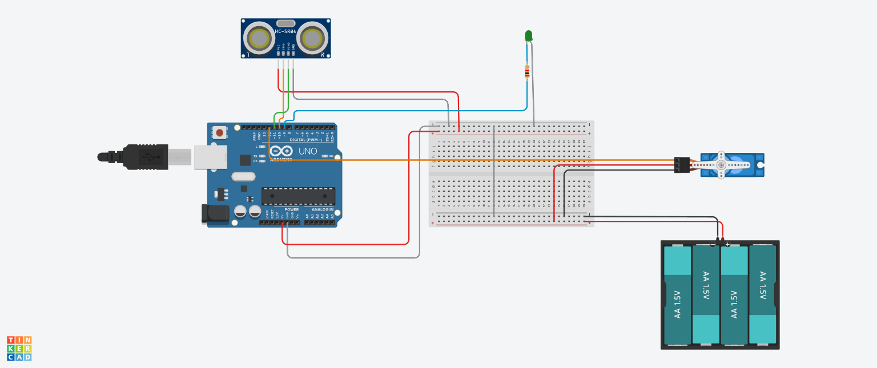

# PROJECT CIRCUITRY SCHEMATIC

